Notice of Public Hearing: Window Cleaning Ordinance
Place: Minneapolis City Hall, Room 317, 350 South 5th Street, Minneapolis, MN 55415
Date: November 29, 2023
Time: 10:30 a.m. or shortly thereafter
The Business, Inspections, Housing & Zoning Committee (BIHZ) of the Minneapolis City Council will consider an ordinance amending Title 13, adding a new Chapter 354 entitled “Window Cleaning” to the Minneapolis Code of Ordinances relating to Licenses and Business Regulations.
A copy of the proposed window cleaning ordinance is available on our website.
You are invited to express your opinions and/or submit such in writing to Public Comment - City of Minneapolis.
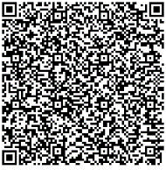
Request accessible format: If you need help with this information, please email 311, or call 311 or 612-673-3000. Please tell us what format you need. It will help us if you say what assistive technology you use. People who are deaf or hard of hearing can use a relay service to call 311 or 612-673-3000.
Information in Other Languages: Para asistencia 612-673-2700. Rau kev pab 612-673-2800. Hadii aad Caawimaad u baahantahay 612-673-3500.

